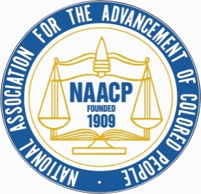

NATIONAL ASSOCIATION FOR THE ADVANCEMENT OF COLORED PEOPLE

Milwaukee Branch Unit # 3254

Fred Royal, President

2745 N. Dr. Martin Luther King Jr. Drive Suite 202, Milwaukee, Wisconsin 53212

Phone: (414) 562-1000 Fax: (414) 562-1091

Email: [naacpmkeorg@gmail.com](mailto:naacpmkeorg@gmail.com) Website: <http://www.naacpmke.org>

Dear Elected officials and candidates,

First of all, let me start by apologizing for the negative tone derived from the flyer sent out from the NAACP- MKE Branch political action committee (PAC) chair. The verbiage utilized in this document was the sole opinion of the committee's chair and not the organization, and had not been approved before being released publicly. As soon as I was aware of the issue, I instructed the PAC chair to remove the language in question and resend the original NAACP approved version via all of its sent outlets.

We agree that the extremely dangerous surge in the Covid-19 virus and infection rates averaging over one thousand per day within the State is a cause for concern in scheduling any in-person events. I wish that a virtual option had been considered. This decision was at the discretion of the chair and should have been brought to the board for discussion and final approval in hindsight. We will be discussing this issue as a board to ensure we can prevent these communication breakdowns in the future.

While all of the committee positions are voluntary, including the PAC Chair position, an individual's private business ventures do not automatically disqualify them from service. We will meet as a board and discuss the potential conflict of interest that may be present within the PAC and any others, and we will create a process to mitigate future issues. Additionally, I understood that the debate was designed to be fair and balanced, with the moderators having party affiliation with Democrats and Republicans. I would also like to point out that the 3rd party candidate's inclusion should have been discussed and decided by the board. This was another breakdown in communication that we will work to ensure never happens again.

As the organization's representative leader, I offer you my sincerest apology for this terrible breakdown in communication. I look forward to working with each of you to determine how we can learn for this and move forward in partnership to address the serious issues that impact and influence our community's standard of living outcomes.

Thank you,

Fred Royal Jr.

President NAACP-MKE Branch